Application for Recognition of a New Technology under SAP Appendix Q

SAP Appendix Q - Introduction

Appendix Q of the Standard Assessment Procedure (SAP) allows new technologies and advanced versions of existing technologies to have their energy saving benefits evaluated for inclusion within SAP. The Building Research Establishment (BRE) author and manage SAP on behalf of the Department for Business, Energy and Industrial Strategy (BEIS) and also operate the Appendix Q scheme.

To maintain the integrity of SAP, any Appendix Q technology must have an energy calculation methodology agreed and accepted. Once this has been achieved, it will be added to the searchable database on the Appendix Q website.

It should be appreciated that in considering technologies, the SAP calculation method must maintain fairness and impartiality. Analytical treatment must remain proportionate to the scope, purpose, and resolution of SAP, and not conflict with existing SAP methodology.

It should be recognised that new ideas and products are often difficult to assess, as they fall outside the traditional assessment methodologies. Reports and test results from other independent third parties can be submitted for consideration; however, these may not be relevant to SAP requirements. Where they exist, relevant EN and BS standards will be considered and reviewed; however, they may not be satisfactory in assessing a new technology. It is also important to note that the methodology used to calculate the potential savings of any technology must be straightforward and easy for a SAP assessor to follow.

Many technologies fall outside the scope of SAP or their energy savings cannot be accounted for in SAP. Any such technologies will not be considered for inclusion in Appendix Q.

Applications from any company attempting to distort the energy savings of a product or products, including falsifying data or reports from independent third parties, will be refused, and where applicable, the relevant third party(s) will be notified.

The SAP Appendix Q procedure must not be used for a technology unless it is listed on the SAP Appendix Q database and the assessment process is undertaken as specified on the Appendix Q website:
https://www.ncm-pcdb.org.uk/sap/page.jsp?id=20.

SAP Appendix Q - Application Process

To have a technology considered for inclusion on the Appendix Q website, the application form (this document) should be completed and emailed to sapq@bre.co.uk.

The application should include:
- Brief description of the technology, specifying the scope of its application and the mechanism by which it operates
- Any relevant standards
- Any limitations as to its application
- Key parameters which will affect the energy use
- Any additional information

The application process for SAP Appendix Q is outlined within the flow chart in Figure 1. As the diagram shows, the first phase of the application process requires the acceptable completion and submission of the application form.

Once the application is received (Stage 1), it will reviewed by BRE and a decision made as to whether the technology is applicable for recognition within SAP. If necessary, an initial preliminary meeting will be held to satisfactorily comprehend the applicant technology (Stage 2). Although typically unnecessary, this preliminary meeting will be held free of charge between the applicant and a member of the SAP Appendix Q administration team to consider any additional relevant information and review the application framework (Stage 3). If an application is unsuccessful during any part of the application process, a formal letter will be issued detailing the reasons.

If the outcome of Stage 2/3 is successful, the application will proceed to a feasibility assessment at a standard upfront fee of £2,000 (Stage 4). This single-page assessment will consider the empirical and theoretical research required for progression of the application to the next stage of the application – the scoping study (Stage 5). The intention of this assessment is a low-risk method for determining the probable scale of the application process, providing a quotation for the subsequent scoping study and where possible, an indicative costing for the entire Appendix Q recognition process.

The scoping study (Stage 5) aims to devise a potential SAP Appendix Q implementation process and provide an indication of the probable energy-savings that can be represented within SAP. The scale of the study is highly variable depending upon the complexity of the technology concerned, with fees determined on an individual application basis.
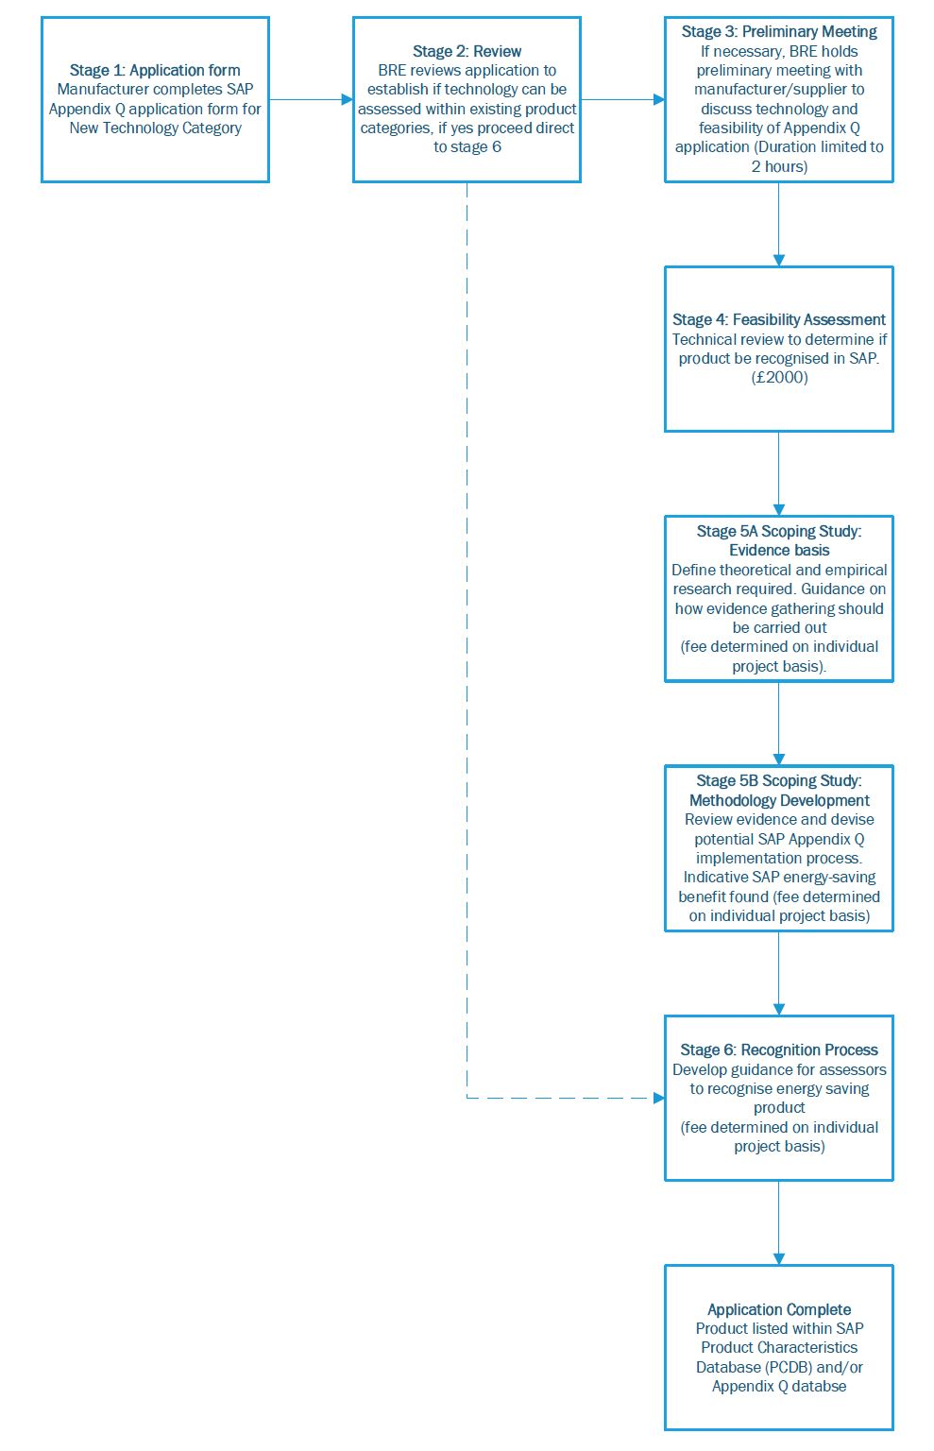
Figure 1 – SAP Appendix Q Application Process

Upon successful progression to the SAP Appendix Q recognition process (Stage 6), an indicative Work Breakdown Structure (WBS) has been provided within
Figure 2 to detail the relevant items likely to be required for successful recognition of the technology.
Figure 2 - SAP Appendix Q recognition process - Work Breakdown Structure (WBS)

Important Note

The SAP Appendix Q application process can take considerable time to complete, depending on the nature of the technology and the complexity of the analysis required. The application costs can therefore be quite high. Applicants may wish to consider applying for support under HMRC’s R&D Tax Credits programme. More information can be found at: http://www.hmrc.gov.uk/ct/forms-rates/claims/randd.htm.
Methodology Development

Any SAP Appendix Q methodology should include a number of key features to ensure the performance data being entered into SAP calculations reflects, as far as practicable, the installed performance. The following framework has been developed to achieve this:
- Identification and clarification of an appropriate test methodology for the key system components. This would ordinarily be based on relevant European or British test standards where available, but could be derived from first principles for certain innovative technologies. The test methodology should produce results that can be utilised directly for the purposes of the SAP calculation.
- Determination of sensitivity of the system to occupant activity e.g. frequency of domestic hot water draw-off
- Determination of sensitivity of the system to construction practices and installation quality e.g. heat distribution pipe work insulation and system commissioning
- Development of calculation procedure and spreadsheet for manufacturer specific test data to be included in SAP calculations. This will incorporate an ‘in-use factor’ that accounts for the above sensitivity analysis and may also include issues such as dwelling orientation, shelter factor, number of devices installed, etc.

Terms of Reference

- SAP is not an approvals or certification scheme
- There is no such thing as a ‘SAP approved’ product
- New methods of analysis in SAP do not confer any measure of approval, and there is no certainty that using them will produce better results than could have been obtained with other products and alternative building designs
- Any calculation methodology included in SAP can only be developed for generic technologies, and will not be restricted to a particular product. The technology generic name will be different from the product name and will be agreed with BRE

Description of products in SAP Appendix Q database or the Product Characteristics Database (PCDB)

- Inclusion of a manufacturer's product or system in the SAP Appendix Q database and/or the Product Characteristics Database (PCDB) does not represent any form of accreditation, certification, approval or recommendation by BRE, SAP, EST, MHCLG or BEIS. Any form of language used in related promotional material or articles must not in any manner suggest otherwise.
- Inclusion in the SAP Appendix Q database and/or the Product Characteristics Database (PCDB) does not grant the manufacturer any right to use the BRE, EST or SAP logos in any format.
- Inclusion in the SAP Appendix Q database and/or the Product Characteristics Database (PCDB) acknowledges that the product has been tested to the appropriate test methodology for recognition of products within the SAP Appendix Q database and/or the Product Characteristics Database (PCDB).
- Systems and/or products in the SAP Appendix Q database can be referred to as 'SAP Appendix Q recognised' but in no circumstances as 'SAP Approved'.

Labelling

- A permanent label, known as an NCM (SAP) Identifier, must be fixed to all recognised products, stating the technology generic name listed in the SAP Appendix Q database and/or the Product Characteristics Database (PCDB) and the unique product name. This should be placed where it is visible after installation, without the need for dismantling or use of tools (otherwise the technology and product cannot be identified by a SAP assessor).
- The wording of the NCM (SAP) Identifier and featured on the label should adhere to the following format:
  - Technology Generic Name
  - Manufacturer
  - Brand
  - Model Name
  - Model Qualifier
  - One of the two statements below:
“This [device] is fitted with a [technology generic name], recognised by the Government’s Standard Assessment Procedure (SAP)”
“This [technology generic name] is recognised by the Government’s Standard Assessment Procedure (SAP)”
- The above combination of brand, model name, and model qualifier (if any) must be a unique identification of the product linked to the technical specification of the product tested and analysed for recognition by SAP.

Applicability of technology within SAP

It is essential to recognise that SAP is an asset-rating tool for the energy rating of dwellings which is based on delivery of standardised levels of delivery for all building services, such as lighting and heating. It does not therefore account for any variability as a result of reducing levels of service delivery, such as Smart Controllers for space heating.

Application Form

To have a technology considered for inclusion on the Appendix Q database, this application form should be completed and sent to: sapq@bre.co.uk.
- Applicant Details

Applicant Name:

Applicant Address:

Contact Person and Position:

Manufacturer or Supplier?:

Telephone Number:

Email Address:

Date of Application:

- Product Details

Relevant Calculation and/or Testing standards:
Type of Product:
Product Name:
Explanation of the technology, specifying the scope of its application and the mechanism by which the technology works:

Control logic explanation (if applicable – an explanation of the technology’s control system logic):

Additional Information:

Limitations to its application:

